**Phase 4**

**Course-end Project 1**

**Developer Details :**

**Seelam Sindhuja**

**Email: ssindhuja@teksystems.com**

**Emp Id : 10840**

**Project Objective :**

The Online Test Application system creates an application that enables users to provide online tests, review them, and display the results.

**Project Overview :**

Project contains three main modules: Quiz, Review, and Result. The quiz section of the online test application accepts the questions in JSON format. The JSON file can be easily shared from the server in the pre-defined format. The application renders the test at the client-side. The “Review and display result” section allows users to declare the results immediately.

**Project Capability :**

The project is capable of conduction quiz to the users and will display result of the test immediately after completion of the test.

**Project Appearance :**

Appearance of the first screen of the project is the welcome screen which asks user to click the start button to start the quiz

**User Interactions :**

User is directed to questions of the test once start button is clicked, every question appears after submission of answer of previous question and finally user can know their score after completion of quiz.

**Project Git hub link :**

https://github.com/SindhujaSeelam/angulardemos/tree/main/myapp/src/app/project

**Sprint Planning :**

I have divided project into 3 sprints.

Sprint 1:

In sprint 1 I have configured all the requirements of the project at first and then designed rough outline of the project. I have first started to designing JSON file consisting of questions and answers of the application.

Sprint 2:

In sprint 2 I have designed the first screen of the project which consists of entry point to test application. Then started to write key components of the project having html, ts and css pages.

Sprint 3:

In sprint 3 I have implemented all front end designing to have easy interaction for the users and also coded all the exceptions that can happen while using application and made connection between all the components and html pages.

Concepts Used:

* JSON Server
* Angular
* Html
* Css
* bootstrap
* json files

**Flowchart of the program**

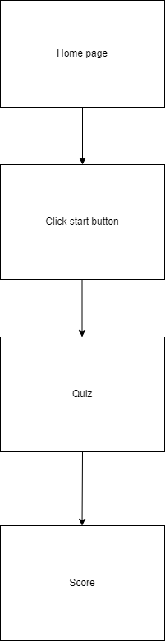

**Algorithm of Application:**

Step 1: START

Step 2: run ng server

Step 3: run json server command to watch json file

Step 4: open url where server is running(localhost:4000)

Step 5 : Displays first screen to start test

Step 6: Click to start to write quiz

Step 7: Answer all the questions by one after other

Step 8: Submit answers

Step 9: Displays Score

Step 10: STOP